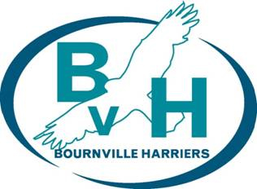
#BvHBingo - Will anyone get a #FullHouse?
Performance – Participation – Encouragement – Enjoyment
Well Being BINGO complete a full house by the 31st October
Write a letter to your ten year old self. What advice would you give yourself? | Draw your favourite place or an image that represents your favourite place | Run or walk a new route | Cook yourself your favourite meal
Clear out that cupboard or drawer that is always cluttered | Make a list of your 5 favourite things about you | Ring a friend you haven’t spoken to for a while and have a chat | Make an hour for yourself to relax and unwind
Enjoy a soak in the bath or a luxurious shower | Make a donation to a food bank or charity shop | Treat yourself, go get that latte, slice of cake, book you want…….. | Go for a walk and litter pick along the way  (please wear gloves)
Make a list of things that may be worrying you, then destroy it. | Read something you enjoy/listen to a podcast | Tell someone that you love them and why you love them | Check on a neighbour or a member of the community, how are they doing?

