Bournville Harriers

**MINUTES OF ZOOM COMMITTEE MEETING**

**Held on Monday 10th August 2020**

Meeting chaired by Rhian Littlewood

Notes taken by Lin Goulding

Attendance

|  |  |  |
| --- | --- | --- |
| **Name** | **Role** |  |
| Rhian Littlewood (RL) | Club Chairperson | ✓ |
| Imogen Peck (IP) | Club Vice Chairperson | ✓ |
| Linda Goulding (LG) | Club Secretary | ✓ |
| Mike Woodall (MW) | Club Treasurer | ✓ |
| John Cheel (JC) | Membership Secretary | ✓ |
| Ian Forman (IF) | Ordinary Member | ✓ |
| Dave Powner (DP) | Ordinary Member | ✓ |
| Suz West (SW) | Head Coach | ✓ |
| Sue Ward (SW) | Race Events Co-ordinator | ✓ |
| Charlie Hurd (CH) | Communications Officer | ✓ |
| Helen McGetterick (HM) | Team Manager Women’s Cross Country | ✓ |
| Ian Mackenzie (IM) | Team Manager Men’s Cross Country | x |
| Xenofon V. Gogouvitis | Team Manager Men’s Road Relays | ✓ |
| Jude Glynn (JG) | Team Manager Women’s Road Relays | ✓ |
| Stewart Crowton (SC) | Membership Development Co-ordinator | ✓ |
| Claire Daniels (CD) | Kit Secretary | ✓ |
| Kristy Mabbett (KM) | Social Secretary | ✓ |

**Apologies**

Ian Mackenzie

**Agenda**

1. Review minutes and action points from July 2020 meeting
2. Non renewals (LG/JC)
3. Coaches update (SW)
4. Covid Issues
5. Club Welfare officers (LG)
6. Virtual Leafy 10k
7. Club Membership update (JC)
8. Club finances update (MW)
9. Club leadership programme (LG)
10. AOB
11. Review minutes and action points from July 2020 meeting

Action Points

* **Follow up on transfers to BRAT** – action point carried forward
* **Covid role –** Claire Daniels has agreed to take on the role of Covid 19 coordinator
* **External accountant –** currently waiting for documents to complete to engage new accountants
* **Steps challenge –** complete
* **Renewals –** on agenda
* **Grass track –** awaiting invoice from RHP
* **Bingo –** in progress
* **Share webinar link -** shared

1. Non renewals (LG/JC)

* The committee agreed that from 31/8/20 all those taking part in coached sessions or virtual events must have renewed their membership and be fully paid up club members, this will be communicated via announcements, and by email, also sharing details of the supported membership option, there will be a count down on the website

1. Coaches update (SW)

* We have taken the strength session offline as not really relevant now that we have coaching bubbles, all the strength sessions are on the website, they will be grouped together into one page
* Re regarding bubble there is a coaching meeting on Wednesday SW will feed back to the committee

1. Covid issues

* No new updated guidance from EA for running clubs

1. Welfare Officers (LG)

* Imogen Peck and Ian Forman have agreed to take on the role of welfare officers, LG will share some links and information.

1. Virtual Leafy 10k

* RL a physical Leafy is not viable and too much effort and responsibility during the current circumstances, DP commented one option would be to have a physical leafy in the spring.
* A subgroup will be set up to consider the possibility and issues of holding a virtual Leafy 10K, cost would just cover a medal, this would maintain the profile of the Leafy.

1. Club membership update (JC)

* 3 members have renewed since the Bingo post, 10 more since my fb post and 25 in total since the last meeting.
* 154 paid up members in total

1. Club finances update (MW)

* Bank balance is slightly (£225) higher than last year, rent has not been paid to RHP for 6 months (£1344) however membership income is down.

1. Club leadership programme

* RL shared details of a development programme being offered by EA, LG will forward details of the programme to the committee, anyone interested to contact Rhian directly in the first instance.

1. AOB

* CH an email has been received from someone wanting to share a research project on mental health and the effects of lockdown, the committee agreed this would be ok to share as relevant, CH will sort.
* XG has shared a report detailing feedback on the recent 4x4x4 virtual race event, report attached below.

# Actions points

|  |  |  |  |
| --- | --- | --- | --- |
|  | **Owner** | **Action** | **Complete / Review** |
| Transfers to BRAT | RL | Send questionnaire to transferees | 14/9/20 |
| Renewals | RL/JC | Include in announcements / send emails | ASAP |
| External accountant | MW | Follow up with LG | 14/9/20 |
| Coaches Meeting | SW | Feedback details to the committee | 14/9/20 |
| Virtual Leafy | RL | Subgroup to consider virtual event | 14/9/20 |
| CLP | LG | Share details of Club Leadership Programme | 14/9/20 |
|  |  |  |  |
|  |  |  |  |
| Members Survey |  | Review previous output | C/Fwd. |
| Run equal |  | Agree wording and information to be shared | C/Fwd. |
| Teal Targets |  | Agree targets and who will track results | C/Fwd. |

Next Meeting: Monday 14th September

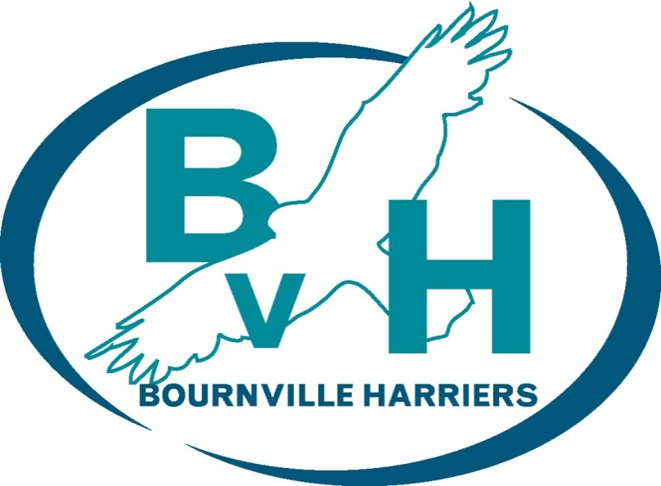

**Bournville Harriers**

**Virtual Event (4x4x4 League) Report**

**As adopted by the members on 10th August 2020**

**

BOURNVILLE HARRIERS

VIRTUAL EVENT (4X4X4 LEAGUE) REPORT

# PREFACE

Due to the lack of actual races as a result of the Covid-19 pandemic, the Bournville Harriers (BvH) committee decided to organise a number of virtual events to provide the club’s members with the opportunity to compete and continue training. One of those virtual events (the 4x4x4 league) was discussed and the committee agreed to proceed with the event throughout a four week period (July 6th – August 2nd).

# EVENT FORMAT

The virtual event “4x4x4 league”, named “BvH444”, consisted of teams of four competing in four virtual events each week (1MTT, 5K TT, 10K TT, Sunday Long Run-SLR) for four weeks. Each team member could run each event only once. Every week, participants were ranked and awarded points from fastest (1 point) to slowest (17 points); in the case of the SLR, points were awarded from longest (1 point) to shortest (17 points). Each participant’s points were added to his/her team total points.

# PARTICIPATION

BvH members were invited to participate via public announcement on the BvH official Facebook page on June 30th, 2020. They were asked to provide their name and their most recent 5K PB (mm:ss) in a Google Form until July 5th, 2020. There were sixty-eight (68) submissions which were ranked from fastest to slowest, based on their submitted 5K time. The participants were subsequently divided into four (4) pools. Dave Powner conducted a draw via facebook live and seventeen (17) teams of four, with one athlete per pool per team, were created. Subsequently, the participants were asked to contact their teammates and choose a captain and a name for their teams. Throughout the four weeks, there were substitutions due to injury or other commitments.

All participating members can be seen in Appendix 1.

# RESULTS

Results were submitted at the end of every week via a respective Google Form by each team’s captain. The results were then collected, spot-checked, and verified. Each week’s results were then collated into a powerpoint presentation and subsequently shared on the BvH official facebook page in video and image format. All the results (per week and final), as well as some statistics, can be seen in Appendix 2.

Each week the Top-3 individuals per category, as well as the Top-3 teams, were recognised (Gold, Silver, Bronze). Similarly, at the end of the league, the Top-3 individuals per category per gender, as well as the Top-3 teams, were recognised. All individuals received a finisher’s badge with their respective results.

|  |  |  |
| --- | --- | --- |
| Team points |  | |
| Solo points |  |  |
| Solo 1M TT |  |  |
| Solo 5K TT |  |  |
| Solo 10K TT |  |  |
| Solo SLR |  |  |

Table . Final standings (Top-3)

# FEEDBACK

After the completion of the league, a survey was created via Google Forms and participants were asked via the BvH official facebook page on August 2nd, 2020, to provide feedback until August 9th, 2020. Questions and tabulated responses can be seen in Appendix 3.

|  |  |  |
| --- | --- | --- |
| SUBMITTED BY | APPROVED BY | |
| Xenofon V. Gogouvitis | Rhian Littlewood | Linda Goulding |
| Organiser | Chairperson | Club Secretary |
| Date: 10-Aug-2020 | Date: | Date: |

Appendix 1 – Participants

Full list of participants (captains in BOLD; red indicates substitution):

|  |  |
| --- | --- |
| **TEAM** | **NAME** |
| Arunderfullife | **Andy Wheeler** |
| Ian Reynolds |
| **Jo Whiting** |
| Michelle Burgess |
| Richard Leaper |
| BeenThereRunThat | Marianne Hensman |
| Pauline Wright |
| Philomena Williamson |
| **Simeon Whiting** |
| Tim Hodges |
| Chafers | Anthony Hayward |
| Charlie Hurd |
| **Chris Owen** |
| Jon Mould |
| Dash | Alice Goodbourn |
| **Andy Hoole** |
| Jennifer Arnold |
| John McKeon |
| Mark Cooper |
| EARS | **Alice Smyth** |
| Chris Hamlett |
| Rachel Hursey |
| Stewart Crowton |
| Frantastics | Claire Daniels |
| Fran Garcia Justicia |
| Sean Rose |
| **Suzanne Bunn** |
| Gadabouts | **Guy Marston** |
| Michaela Thompson |
| Sam Weaver |
| Sharon Newman |
| HmakesSteps | **Dave Powner** |
| Jonny Bellman |
| Kevin Peace |
| Steph Allen |
| Impala | Dave Harte |
| **Ian Forman** |
| Mathilde Housley |
| Paul Samuels |
| Jigglypuffs | Charlie Burn |
| **Laura Gale** |
| Rob Styles |
| Stacey Marston |
| Kipchoge | Helen McGettrick |
| Rebecca Jones |
| Sara Hewison |
| Simon Gardner |
| **Xenofon V. Gogouvitis** |
| Legalicious | Grant Newman |
| Jim Clarke |
| Jude Glynn |
| **Kristy Mabbett** |
| Miscalculations | **Alison Price** |
| James Evans |
| Martin Foster |
| Steve Doswell |
| N-ergize | **Helen Clayton** |
| John Cheel |
| Maeve Kenny |
| Pete Hickman |
| Omnishambles | **Clare Mullin** |
| Jaeda Goodman |
| Richard Shearing |
| Tom Robinson |
| Perfection | Barrie Roberts |
| Heather Tyrie |
| Mike Woodall |
| **Oliver Kirkland** |
| Renegades | **Jo Green** |
| Karen Harper |
| Lorna Al-Ani |
| Sam Gallagher |
| Stuart Bird |

Table . BvH444 participants

Appendix 2 – Results

|  |  |  |  |  |  |  |  |  |  |  |  |  |
| --- | --- | --- | --- | --- | --- | --- | --- | --- | --- | --- | --- | --- |
| **Week 1 – 1M TT** | | | | |  | **Week 1 – 5K TT** | | | | | | |
| Team | Runner | Time | Ranking | |  | Team | | Runner | Time | | Ranking | |
| HmakesSteps | Jonny Bellman | 00:05:14 | 1 | |  | Frantastics | | Sean rose | 00:19:14 | | 1 | |
| Kipchoge | Xenofon V. Gogouvitis | 00:05:40 | 2 | |  | Legalicious | | Grant Newman | 00:19:14 | | 1 | |
| Gadabouts | Sam Weaver | 00:05:46 | 3 | |  | EARS | | Alice Smyth | 00:22:16 | | 3 | |
| Omnishambles | Richard Shearing | 00:05:46 | 3 | |  | Jigglypuffs | | Laura Gale | 00:23:23 | | 4 | |
| Dash | Andy Hoole | 00:06:08 | 5 | |  | Arunderfullife | | Richard Leaper | 00:23:52 | | 5 | |
| BeenThereRunThat | Tim Hodges | 00:06:25 | 6 | |  | Gadabouts | | Michaela Thompson | 00:23:52 | | 5 | |
| Impala | Dave Harte | 00:06:34 | 7 | |  | Impala | | Ian Forman | 00:24:10 | | 7 | |
| Chafers | Charlie Hurd | 00:06:41 | 8 | |  | BeenThereRunThat | | Marianne Hensman | 00:24:22 | | 8 | |
| Renegades | Jo Green | 00:07:10 | 9 | |  | Renegades | | Stuart Bird | 00:24:44 | | 9 | |
| EARS | Chris Hamlett | 00:07:13 | 10 | |  | Dash | | Alice Goodbould | 00:25:31 | | 10 | |
| Jigglypuffs | Rob Styles | 00:07:24 | 11 | |  | Omnishambles | | Clare Mullin | 00:25:40 | | 11 | |
| Perfection | Heather Tyrie | 00:07:29 | 12 | |  | N-ergize | | John Cheel | 00:25:42 | | 12 | |
| Legalicious | Kristy Mabbett | 00:07:32 | 13 | |  | Miscalculations | | Martin Foster | 00:27:47 | | 13 | |
| Miscalculations | Steve Doswell | 00:07:42 | 14 | |  | Perfection | | Barrie Roberts | 00:28:03 | | 14 | |
| N-ergize | Helen Clayton | 00:07:45 | 15 | |  | Kipchoge | | Simon Gardner | 00:28:11 | | 15 | |
| Arunderfullife | Jo Whiting | 00:08:57 | 16 | |  | HmakesSteps | | Steph Allen | 00:29:52 | | 16 | |
| Frantastics | Claire Daniels | 00:10:58 | 17 | |  | Chafers | | Anthony Hayward | 00:30:42 | | 17 | |
|  | | | | |  |  | | | | | | |
| **Week 1 – 10K TT** | | | | |  | **Week 1 - SLR** | | | | | | |
| Team | Runner | Time | | Ranking |  | Team | Runner | | | Distance | | Ranking |
| Jigglypuffs | Charlie Burn | 00:40:42 | | 1 |  | Frantastics | Suzanne Bunn | | | 26.3 | | 1 |
| N-ergize | Maeve Kenny | 00:42:04 | | 2 |  | Legalicious | Jude Glynn | | | 21.04 | | 2 |
| BeenThereRunThat | Simeon Whiting | 00:42:54 | | 3 |  | Kipchoge | Rebecca Jones | | | 20.55 | | 3 |
| Renegades | Lorna Al-Ani | 00:43:01 | | 4 |  | Impala | Mathilde Housley | | | 19.21 | | 4 |
| Miscalculations | Alison Price | 00:43:17 | | 5 |  | N-ergize | Pete Hickman | | | 18.51 | | 5 |
| Legalicious | Jim Clarke | 00:43:49 | | 6 |  | BeenThereRunThat | Philomena Wilkinson | | | 18 | | 6 |
| Dash | John McKeon | 00:44:15 | | 7 |  | Jigglypuffs | Stacey Marston | | | 17.53 | | 7 |
| Perfection | Mike Woodall | 00:45:47 | | 8 |  | Omnishambles | Tom Robinson | | | 17.08 | | 8 |
| Arunderfullife | Andy Wheeler | 00:46:12 | | 9 |  | HmakesSteps | Kevin Peace | | | 15.52 | | 9 |
| Gadabouts | Guy Marston | 00:47:47 | | 10 |  | EARS | Rachel Hursey | | | 15.03 | | 10 |
| Omnishambles | Jaeda Goodman | 00:49:26 | | 11 |  | Miscalculations | James Evans | | | 14.52 | | 11 |
| Frantastics | Fran javier | 00:49:58 | | 12 |  | Arunderfullife | Ian Reynolds | | | 13.55 | | 12 |
| HmakesSteps | Dave Powner | 00:52:39 | | 13 |  | Perfection | Oliver Kirkland | | | 13.5 | | 13 |
| Chafers | Chris Owen | 00:55:27 | | 14 |  | Renegades | Karen Harper | | | 12.39 | | 14 |
| Kipchoge | Helen McGettrick | 00:55:53 | | 15 |  | Chafers | Jon Mould | | | 11.13 | | 15 |
| Impala | Paul Samuels | 00:57:32 | | 16 |  | Gadabouts | Sharon Newman | | | 10.04 | | 16 |
| EARS | Stewart Crowton | 01:01:09 | | 17 |  | Dash | Mark Cooper | | | 7.13 | | 17 |

Table . Week 1 results



Figure . Week 1 statistics

|  |  |  |
| --- | --- | --- |
| **Position** | **Team** | **Points** |
| 1 | Legalicious | 22 |
| 2 | BeenThereRunThat | 23 |
| 2 | Jigglypuffs | 23 |
| 4 | Frantastics | 31 |
| 5 | Omnishambles | 33 |
| 6 | Gadabouts | 34 |
| 6 | Team I | 34 |
| 6 | N-ergize | 34 |
| 9 | Kipchoge | 35 |
| 10 | Renegades | 36 |
| 11 | DASH | 39 |
| 11 | HmakesSteps | 39 |
| 13 | EARS | 40 |
| 14 | Arunderfullife | 42 |
| 15 | Miscalculations | 43 |
| 16 | Perfection | 47 |
| 17 | Chafers | 54 |

Table . Week 1 team points

|  |  |  |  |  |  |  |  |  |  |  |  |  |  |
| --- | --- | --- | --- | --- | --- | --- | --- | --- | --- | --- | --- | --- | --- |
| **Week 2 – 1M TT** | | | | | |  | **Week 2 – 5K TT** | | | | | | |
| Team | Runner | | Time | Ranking | |  | Team | | Runner | Time | | Ranking | |
| Frantastics | Sean rose | | 00:05:23 | 1 | |  | BeenThereRunThat | | Simeon Whiting | 00:19:33 | | 1 | |
| Legalicious | Grant Newman | | 00:05:29 | 2 | |  | Miscalculations | | Ali Price | 00:19:42 | | 2 | |
| Miscalculations | James Evans | | 00:05:58 | 3 | |  | Legalicious | | Jim Clarke | 00:20:42 | | 3 | |
| HmakesSteps | Dave Powner | | 00:06:03 | 4 | |  | Dash | | John McKeon | 00:20:55 | | 4 | |
| Renegades | Sam Gallagher | | 00:06:33 | 5 | |  | Omnishambles | | Tom Robinson | 00:20:57 | | 5 | |
| Impala | Mathilde Housley | | 00:06:34 | 6 | |  | Frantastics | | Fran | 00:23:45 | | 6 | |
| N-ergize | Pete Hickman | | 00:06:38 | 7 | |  | Gadabouts | | Guy Marston | 00:24:00 | | 7 | |
| Jigglypuffs | Laura Gale | | 00:06:39 | 8 | |  | EARS | | Chris Hamlett | 00:24:10 | | 8 | |
| Kipchoge | Rebecca Jones | | 00:06:51 | 9 | |  | HmakesSteps | | Kevin Peace | 00:24:58 | | 9 | |
| Omnishambles | Jaeda Goodman | | 00:06:57 | 10 | |  | Chafers | | Chris Owen | 00:25:30 | | 10 | |
| Dash | Alice Goodburn | | 00:07:15 | 11 | |  | Kipchoge | | Helen McGettrick | 00:25:46 | | 11 | |
| EARS | Rachel Hursey | | 00:07:29 | 12 | |  | Jigglypuffs | | Rob Styles | 00:26:44 | | 12 | |
| BeenThereRunThat | Philomena Williamson | | 00:07:59 | 13 | |  | Impala | | Paul Samuels | 00:26:59 | | 13 | |
| Arunderfullife | Ian Reynolds | | 00:08:07 | 14 | |  | N-ergize | | Helen Clayton | 00:27:17 | | 14 | |
| Perfection | Barrie Roberts | | 00:08:12 | 15 | |  | Perfection | | Heather Tyrie | 00:28:23 | | 15 | |
| Chafers | Anthony Hayward | | 00:08:35 | 16 | |  | Renegades | | Karen Harper | 00:30:16 | | 16 | |
| Gadabouts | Sharon Newman | | 00:08:52 | 17 | |  | Arunderfullife | | Jo Whiting | 00:34:36 | | 17 | |
|  | | | | | |  |  | | | | | | |
| **Week 2 – 10K TT** | | | | | |  | **Week 2 - SLR** | | | | | | |
| Team | Runner | Time | | | Ranking |  | Team | Runner | | | Distance | | Ranking |
| Perfection | Oliver Kirkland | 00:40:53 | | | 1 |  | Miscalculations | Steve Doswell | | | 26.2 | | 1 |
| Kipchoge | Xenofon V. Gogouvitis | 00:41:50 | | | 2 |  | HmakesSteps | Jonny Bellman | | | 20.91 | | 2 |
| Gadabouts | Sam Weaver | 00:42:49 | | | 3 |  | Dash | Andy Hoole | | | 20 | | 3 |
| Chafers | Jon Mould | 00:43:03 | | | 4 |  | Legalicious | Kristy Mabbett | | | 19.51 | | 4 |
| EARS | Alice Smyth | 00:47:16 | | | 5 |  | Impala | Ian Forman | | | 18.64 | | 5 |
| Legalicious | Jude Glynn | 00:48:20 | | | 6 |  | Perfection | Mike Woodall | | | 18.12 | | 6 |
| BeenThereRunThat | Tim Hodges | 00:49:10 | | | 7 |  | Arunderfullife | Andy Wheeler | | | 16.7 | | 7 |
| Impala | Dave Harte | 00:51:00 | | | 8 |  | N-ergize | Maeve Kenny | | | 16.28 | | 8 |
| Arunderfullife | Richard Leaper | 00:52:41 | | | 9 |  | Jigglypuffs | Charlie Burn | | | 16.24 | | 9 |
| N-ergize | John Cheel | 00:54:49 | | | 10 |  | Kipchoge | Simon Gardner | | | 15.01 | | 10 |
| Jigglypuffs | Stacey Marston | 00:55:16 | | | 11 |  | Omnishambles | Richard Shearing | | | 14.25 | | 11 |
| Renegades | Stuart Bird | 00:55:23 | | | 12 |  | Chafers | Charlie Hurd | | | 14.08 | | 12 |
| Omnishambles | Clare Mullin | 00:56:53 | | | 13 |  | Renegades | Jo Green | | | 13.2 | | 13 |
| Miscalculations | Martin Foster | 00:59:31 | | | 14 |  | Frantastics | Claire Daniels | | | 13.17 | | 14 |
| Frantastics | Suzanne bun | 01:00:39 | | | 15 |  | Gadabouts | Michaela Thompson | | | 12.06 | | 15 |
| Dash | Jennifer Arnold | 01:02:29 | | | 16 |  | EARS | Stewart Crowton | | | 10.64 | | 16 |
| HmakesSteps | Steph Allen | 01:05:23 | | | 17 |  | BeenThereRunThat | Marianne Hensman | | | 9.5 | | 17 |

Table . Week 2 results



Figure . Week 2 statistics

|  |  |  |
| --- | --- | --- |
| **Position** | **Team** | **Points** |
| 1 | Legalicious | 15 |
| 2 | Miscalculations | 20 |
| 3 | HmakesSteps | 32 |
| - | Impala | 32 |
| - | Kipchoge | 32 |
| 6 | Dash | 34 |
| 7 | Frantastics | 36 |
| 8 | Perfection | 37 |
| 9 | BeenThereRunThat | 38 |
| 10 | Omnishambles | 39 |
| - | N-ergize | 39 |
| 12 | Jigglypuffs | 40 |
| 13 | EARS | 41 |
| 14 | Chafers | 42 |
| - | Gadabouts | 42 |
| 16 | Renegades | 46 |
| 17 | Arunderfullife | 47 |

Table . Week 2 team points

|  |  |  |  |  |  |  |  |  |  |  |  |  |
| --- | --- | --- | --- | --- | --- | --- | --- | --- | --- | --- | --- | --- |
| **Week 3 – 1M TT** | | | | |  | **Week 3 – 5K TT** | | | | | | |
| Team | Runner | Time | Ranking | |  | Team | Runner | | Time | | Ranking | |
| Jigglypuffs | Charlie Burn | 00:05:21 | 1 | |  | HmakesSteps | Jonny Bellman | | 00:18:48 | | 1 | |
| Chafers | Jon Mould | 00:05:44 | 2 | |  | Perfection | Oliver Kirkland | | 00:19:28 | | 2 | |
| Legalicious | Jim Clark | 00:05:52 | 3 | |  | N-ergize | Maeve Kenny | | 00:19:33 | | 3 | |
| Omnishambles | Tom Robinson | 00:05:53 | 4 | |  | Gadabouts | Sam Weaver | | 00:19:49 | | 4 | |
| Dash | John McKeon | 00:06:00 | 5 | |  | Impala | Dave Harte | | 00:20:21 | | 5 | |
| Perfection | Mike Woodall | 00:06:30 | 6 | |  | Arunderfullife | Andy Wheeler | | 00:20:23 | | 6 | |
| Renegades | Stuart Bird | 00:06:42 | 7 | |  | Kipchoge | Rebecca Jones | | 00:22:02 | | 7 | |
| Gadabouts | Michaela Thompson | 00:06:48 | 8 | |  | Renegades | Jo Green | | 00:22:09 | | 8 | |
| Frantastics | Fran | 00:06:53 | 9 | |  | BeenThereRunThat | Tim Hodges | | 00:22:38 | | 9 | |
| BeenThereRunThat | Marianne Hensman | 00:06:55 | 10 | |  | Chafers | Charlie Hurd | | 00:23:05 | | 10 | |
| Impala | Ian Forman | 00:06:58 | 11 | |  | Legalicious | Jude Glynn | | 00:23:30 | | 11 | |
| EARS | Stewart Crowton | 00:07:11 | 13 | |  | Omnishambles | Jaeda Goodman | | 00:23:41 | | 12 | |
| Arunderfullife | Richard Leaper | 00:07:01 | 12 | |  | Miscalculations | Steve Doswell | | 00:25:43 | | 13 | |
| Kipchoge | Helen McGettrick | 00:07:24 | 14 | |  | EARS | Rachel Hursey | | 00:26:11 | | 14 | |
| N-ergize | John Cheel | 00:07:26 | 15 | |  | Jigglypuffs | Stacey Marston | | 00:26:25 | | 15 | |
| Miscalculations | Martin Foster | 00:08:17 | 16 | |  | Frantastics | Suzanne bunn | | 00:29:01 | | 16 | |
| HmakesSteps | Steph Allen | 00:08:30 | 17 | |  | Dash | Jenny Arnold | | 00:29:55 | | 17 | |
|  | | | | |  |  | | | | | | |
| **Week 3 – 10K TT** | | | | |  | **Week 3 - SLR** | | | | | | |
| Team | Runner | Time | | Ranking |  | Team | | Runner | | Distance | | Ranking |
| Dash | Andy Hoole | 00:42:09 | | 1 |  | BeenThereRunThat | | Simeon Whiting | | 36.91 | | 1 |
| Omnishambles | Richard Shearing | 00:46:21 | | 2 |  | Gadabouts | | Guy Marston | | 36.91 | | 1 |
| N-ergize | Pete Hickman | 00:47:02 | | 3 |  | Miscalculations | | Alison Price | | 36.91 | | 1 |
| Kipchoge | Simon Gardner | 00:47:51 | | 4 |  | Renegades | | Lorna (machine) Al-Ani | | 36.91 | | 1 |
| Miscalculations | James Evans | 00:48:10 | | 5 |  | Kipchoge | | Xenofon V. Gogouvitis | | 23.29 | | 5 |
| Impala | Mathilde Housley | 00:50:38 | | 6 |  | Legalicious | | Grant Newman | | 23.29 | | 5 |
| HmakesSteps | Kevin Peace | 00:53:33 | | 7 |  | Frantastics | | Sean rose | | 21.06 | | 7 |
| Legalicious | Kristy Mabbett | 00:56:00 | | 8 |  | EARS | | Alice Smyth | | 21.02 | | 8 |
| EARS | Chris Hamlett | 00:56:38 | | 9 |  | Omnishambles | | Clare Mullin | | 20.5 | | 9 |
| BeenThereRunThat | Philomena Williamson | 00:59:00 | | 10 |  | Jigglypuffs | | Laura Gale | | 18.01 | | 10 |
| Jigglypuffs | Rob Styles | 00:59:35 | | 11 |  | Impala | | Paul Samuels | | 16.25 | | 11 |
| Chafers | Anthony Hayward | 01:01:00 | | 12 |  | Chafers | | Chris Owen | | 13.38 | | 12 |
| Perfection | Barrie Roberts | 01:02:10 | | 13 |  | N-ergize | | Helen Clayton | | 13.2 | | 13 |
| Arunderfullife | Michelle Burgess | 01:02:58 | | 14 |  | Dash | | Alice Goodbould | | 13.16 | | 14 |
| Gadabouts | Sharon Newman | 01:04:18 | | 15 |  | Perfection | | Heather Tyrie | | 12 | | 15 |
| Renegades | Karen Harper | 01:04:43 | | 16 |  | Arunderfullife | | Jo Whiting | | 11.1 | | 16 |
| Frantastics | Claire Daniels | 01:13:13 | | 17 |  | HmakesSteps | | Dave Powner | | 10.64 | | 17 |

Table . Week 3 results



Figure . Week 3 statistics

|  |  |  |
| --- | --- | --- |
| **Position** | **Team** | **Points** |
| 1 | Legalicious | 27 |
| - | Omnishambles | 27 |
| 2 | Gadabouts | 28 |
| 3 | BeenThereRunThat | 30 |
| - | Kipchoge | 30 |
| 4 | Renegades | 32 |
| 5 | Impala | 33 |
| 6 | N-ergize | 34 |
| 7 | Miscalculations | 35 |
| 8 | Chafers | 36 |
| - | Perfection | 36 |
| 9 | Dash | 37 |
| - | Jigglypuffs | 37 |
| 10 | HmakesSteps | 42 |
| 11 | EARS | 44 |
| 12 | Arunderfullife | 48 |
| 13 | Frantastics | 49 |

Table . Week 3 team points

|  |  |  |  |  |  |  |  |  |  |  |  |  |  |
| --- | --- | --- | --- | --- | --- | --- | --- | --- | --- | --- | --- | --- | --- |
| **Week 4 – 1M TT** | | | | | |  | **Week 4 – 5K TT** | | | | | | |
| Team | Runner | | Time | Ranking | |  | Team | | Runner | Time | | Ranking | |
| Arunderfullife | Andy Wheeler | | 00:05:24 | 1 | |  | Jigglypuffs | | Charlie Burn | 00:18:21 | | 1 | |
| Miscalculations | Alison Price | | 00:05:47 | 2 | |  | Kipchoge | | Xenofon V. Gogouvitis | 00:19:22 | | 2 | |
| BeenThereRunThat | Simeon Whiting | | 00:05:49 | 3 | |  | Chafers | | Jon Mould | 00:20:18 | | 3 | |
| N-ergize | Maeve Kenny | | 00:05:49 | 3 | |  | Dash | | Andy Hoole | 00:20:42 | | 4 | |
| Perfection | Oliver Kirkland | | 00:05:56 | 5 | |  | Miscalculations | | James Evans | 00:21:02 | | 5 | |
| Kipchoge | Simon Gardner | | 00:06:17 | 6 | |  | Renegades | | Lorna Al-Ani | 00:22:01 | | 6 | |
| EARS | Alice Smyth | | 00:06:29 | 7 | |  | N-ergize | | Pete Hickman | 00:22:15 | | 7 | |
| Legalicious | Jude Glynn | | 00:07:01 | 8 | |  | Perfection | | Mike Woodall | 00:22:48 | | 8 | |
| Gadabouts | Guy Marston | | 00:07:15 | 9 | |  | Omnishambles | | Richard Shearing | 00:22:53 | | 9 | |
| Chafers | Chris Owen | | 00:07:17 | 10 | |  | Impala | | Mathilde Housley | 00:23:09 | | 10 | |
| HmakesSteps | Kevin Peace | | 00:07:26 | 11 | |  | HmakesSteps | | Dave Powner | 00:23:18 | | 11 | |
| Jigglypuffs | Stacey Marston | | 00:07:50 | 12 | |  | Legalicious | | Kristy Mabbett | 00:24:25 | | 12 | |
| Omnishambles | Clare Mullin | | 00:07:51 | 13 | |  | EARS | | Stewart Crowton | 00:25:46 | | 13 | |
| Frantastics | Suzanne | | 00:08:10 | 14 | |  | BeenThereRunThat | | Pauline Wright | 00:28:00 | | 14 | |
| Impala | Paul Samuels | | 00:08:27 | 15 | |  | Arunderfullife | | Michelle Burgess | 00:28:11 | | 15 | |
| Dash | Jenny Arnold | | 00:08:42 | 16 | |  | Gadabouts | | Sharon Newman | 00:31:09 | | 16 | |
| Renegades | Karen Harper | | 00:09:09 | 17 | |  | Frantastics | | Claire | 00:34:45 | | 17 | |
|  | | | | | |  |  | | | | | | |
| **Week 4 – 10K TT** | | | | | |  | **Week 4 - SLR** | | | | | | |
| Team | Runner | Time | | | Ranking |  | Team | Runner | | | Distance | | Ranking |
| HmakesSteps | Jonny Bellman | 00:39:10 | | | 1 |  | Gadabouts | Sam Weaver | | | 28.29 | | 1 |
| Legalicious | Grant Newman | 00:39:54 | | | 2 |  | Frantastics | Fran Garcia Justicia | | | 26.5 | | 2 |
| Frantastics | Sean | 00:40:53 | | | 3 |  | Jigglypuffs | Rob Styles | | | 21.4 | | 3 |
| Omnishambles | Tom Robinson | 00:43:57 | | | 4 |  | Perfection | Barrie Roberts | | | 21.13 | | 4 |
| Jigglypuffs | Laura Gale | 00:47:55 | | | 5 |  | Legalicious | Jim Clarke | | | 20.33 | | 5 |
| BeenThereRunThat | Marianne Hensman | 00:48:01 | | | 6 |  | Kipchoge | Sara Hewson | | | 20.05 | | 6 |
| Kipchoge | Rebecca Jones | 00:49:05 | | | 7 |  | BeenThereRunThat | Tim Hodges | | | 20.04 | | 7 |
| Chafers | Charlie Hurd | 00:49:39 | | | 8 |  | Omnishambles | Jaeda Goodman | | | 16.09 | | 8 |
| Renegades | Jo Green | 00:50:43 | | | 9 |  | Dash | John McKeon | | | 15.5 | | 9 |
| Miscalculations | Steve Doswell | 00:52:25 | | | 10 |  | Impala | Dave Harte | | | 15.06 | | 10 |
| Dash | Alice Goodbould | 00:54:01 | | | 11 |  | HmakesSteps | Steph Allen | | | 13.5 | | 11 |
| Gadabouts | Michaela Thompson | 00:54:40 | | | 12 |  | Arunderfullife | Richard Leaper | | | 13.11 | | 12 |
| Impala | Ian Forman | 00:55:04 | | | 13 |  | Chafers | Anthony Hayward | | | 12.67 | | 13 |
| EARS | Rachel Hursey | 00:55:16 | | | 14 |  | N-ergize | John Cheel | | | 11.6 | | 14 |
| Perfection | Heather Tyrie | 00:55:32 | | | 15 |  | EARS | Chris Hamlett | | | 11.5 | | 15 |
| N-ergize | Helen Clayton | 00:59:38 | | | 16 |  | Renegades | Stuart Bird | | | 9.95 | | 16 |
| Arunderfullife | Jo Whiting | 01:08:34 | | | 17 |  | Miscalculations | Martin Foster | | | 8.18 | | 17 |

Table . Week 4 results



Figure . Week 4 statistics

|  |  |  |
| --- | --- | --- |
| **Position** | **Team** | **Points** |
| 1 | Jigglypuffs | 21 |
| - | Kipchoge | 21 |
| 2 | Legalicious | 27 |
| 3 | BeenThereRunThat | 30 |
| 4 | Perfection | 32 |
| 5 | Chafers | 34 |
| - | HmakesSteps | 34 |
| - | Miscalculations | 34 |
| - | Omnishambles | 34 |
| 6 | Frantastics | 36 |
| 7 | Gadabouts | 38 |
| 8 | Dash | 40 |
| 9 | N-ergize | 41 |
| 10 | Arunderfullife | 45 |
| 11 | Impala | 48 |
| - | Renegades | 48 |
| 12 | EARS | 49 |

Table . Week 4 team points



Figure . Cumulative stats and progression

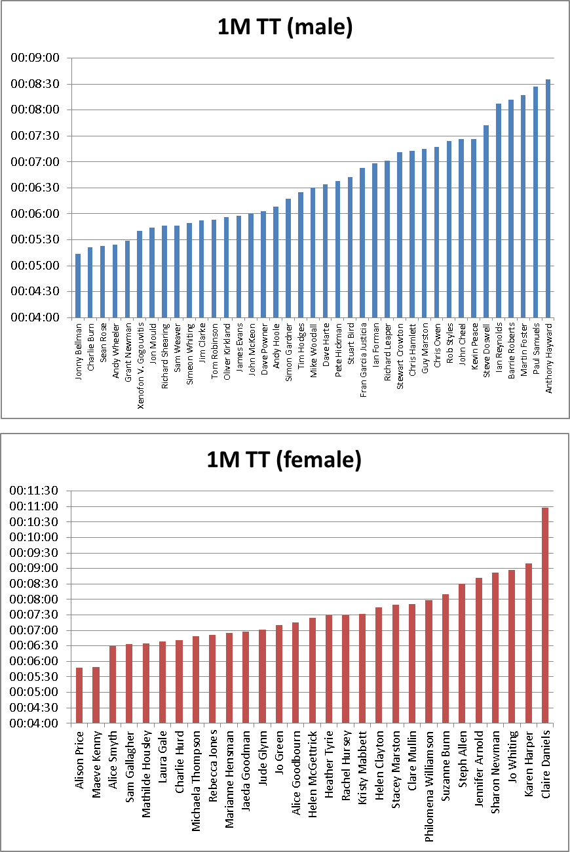

Figure . Final standings - 1M TT

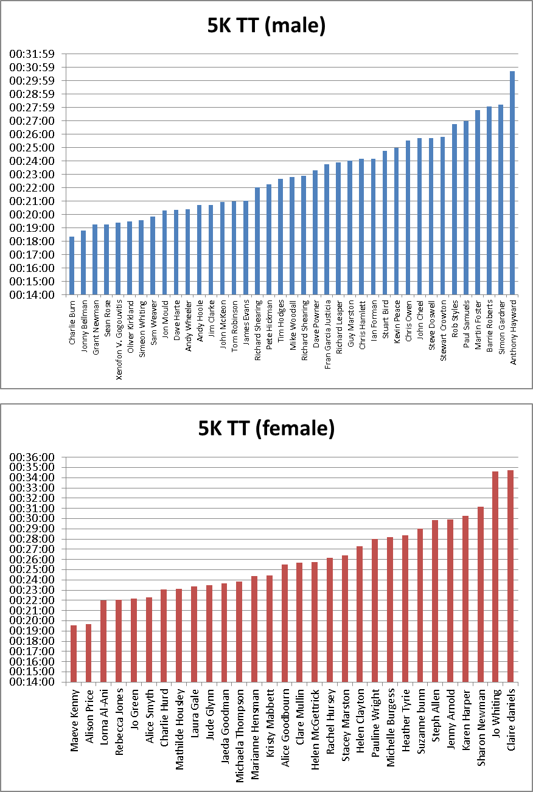

Figure . Final standings (5K TT)

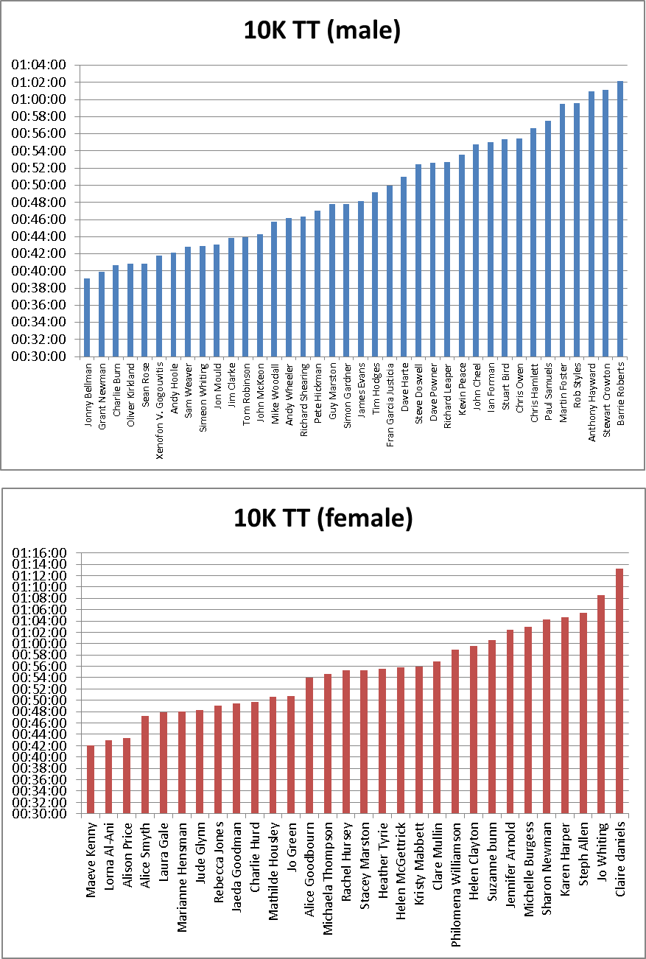

Figure . Final standings (10K TT)

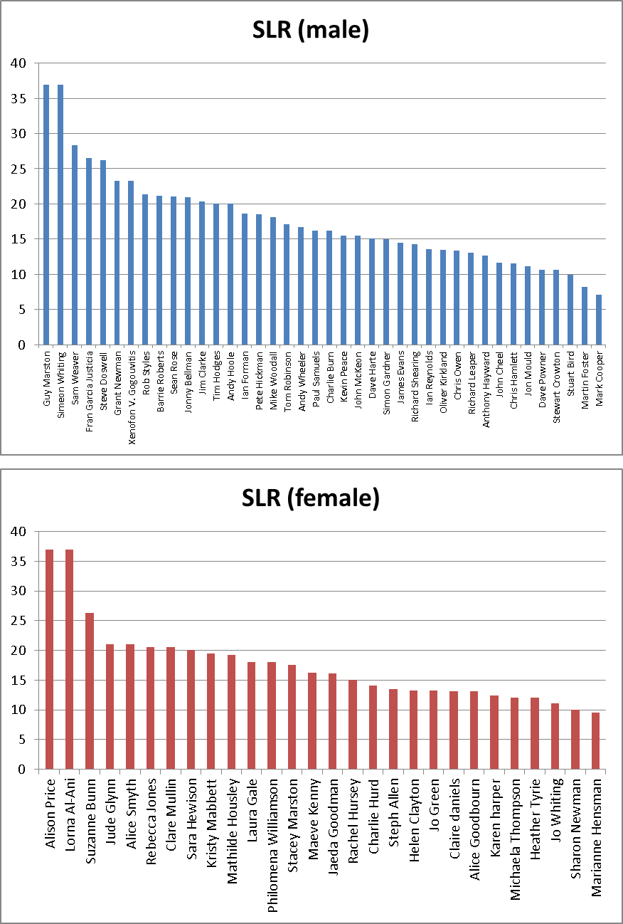

Figure . Final standings (SLR)

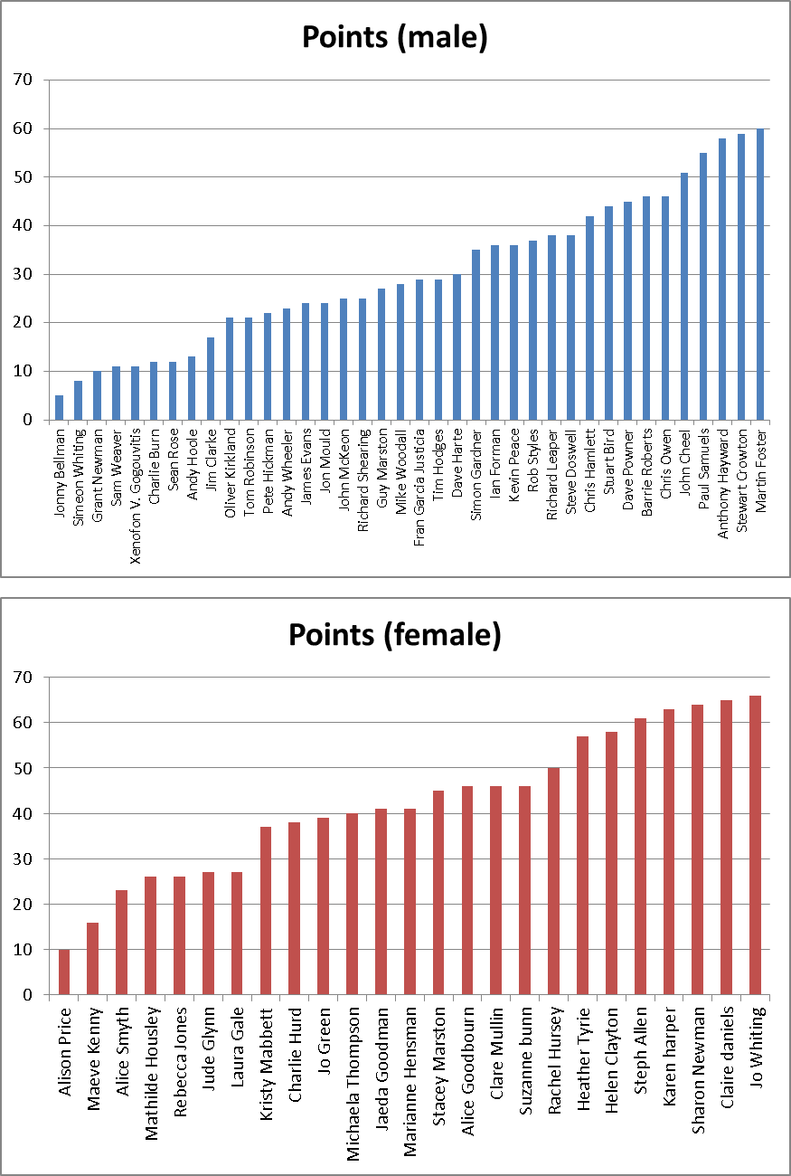

Figure . Final standings (individual points)

|  |  |  |  |  |  |  |
| --- | --- | --- | --- | --- | --- | --- |
| Position | Team | Points | Week 1 | Week 2 | Week 3 | Week 4 |
| 1 | Legalicious | 91 | 22 | 15 | 27 | 27 |
| 2 | Kipchoge | 118 | 35 | 32 | 30 | 21 |
| 3 | BeenThereRunThat | 121 | 23 | 38 | 30 | 30 |
| - | Jigglypuffs | 121 | 23 | 40 | 37 | 21 |
| 5 | Miscalculations | 132 | 43 | 20 | 35 | 34 |
| 6 | Omnishambles | 133 | 33 | 39 | 27 | 34 |
| 7 | Gadabouts | 142 | 34 | 42 | 28 | 38 |
| 8 | HmakesSteps | 147 | 39 | 32 | 42 | 34 |
| - | Impala | 147 | 34 | 32 | 33 | 48 |
| - | N-ergize | 147 | 34 | 39 | 34 | 40 |
| 11 | Dash | 150 | 39 | 34 | 37 | 40 |
| 12 | Frantastics | 152 | 31 | 36 | 49 | 36 |
| - | Perfection | 152 | 47 | 37 | 36 | 32 |
| 14 | Renegades | 162 | 36 | 46 | 32 | 48 |
| 15 | Chafers | 166 | 54 | 42 | 36 | 34 |
| 16 | EARS | 174 | 40 | 41 | 44 | 49 |
| 17 | Arunderfullife | 182 | 42 | 47 | 48 | 45 |

Figure . Final league standings

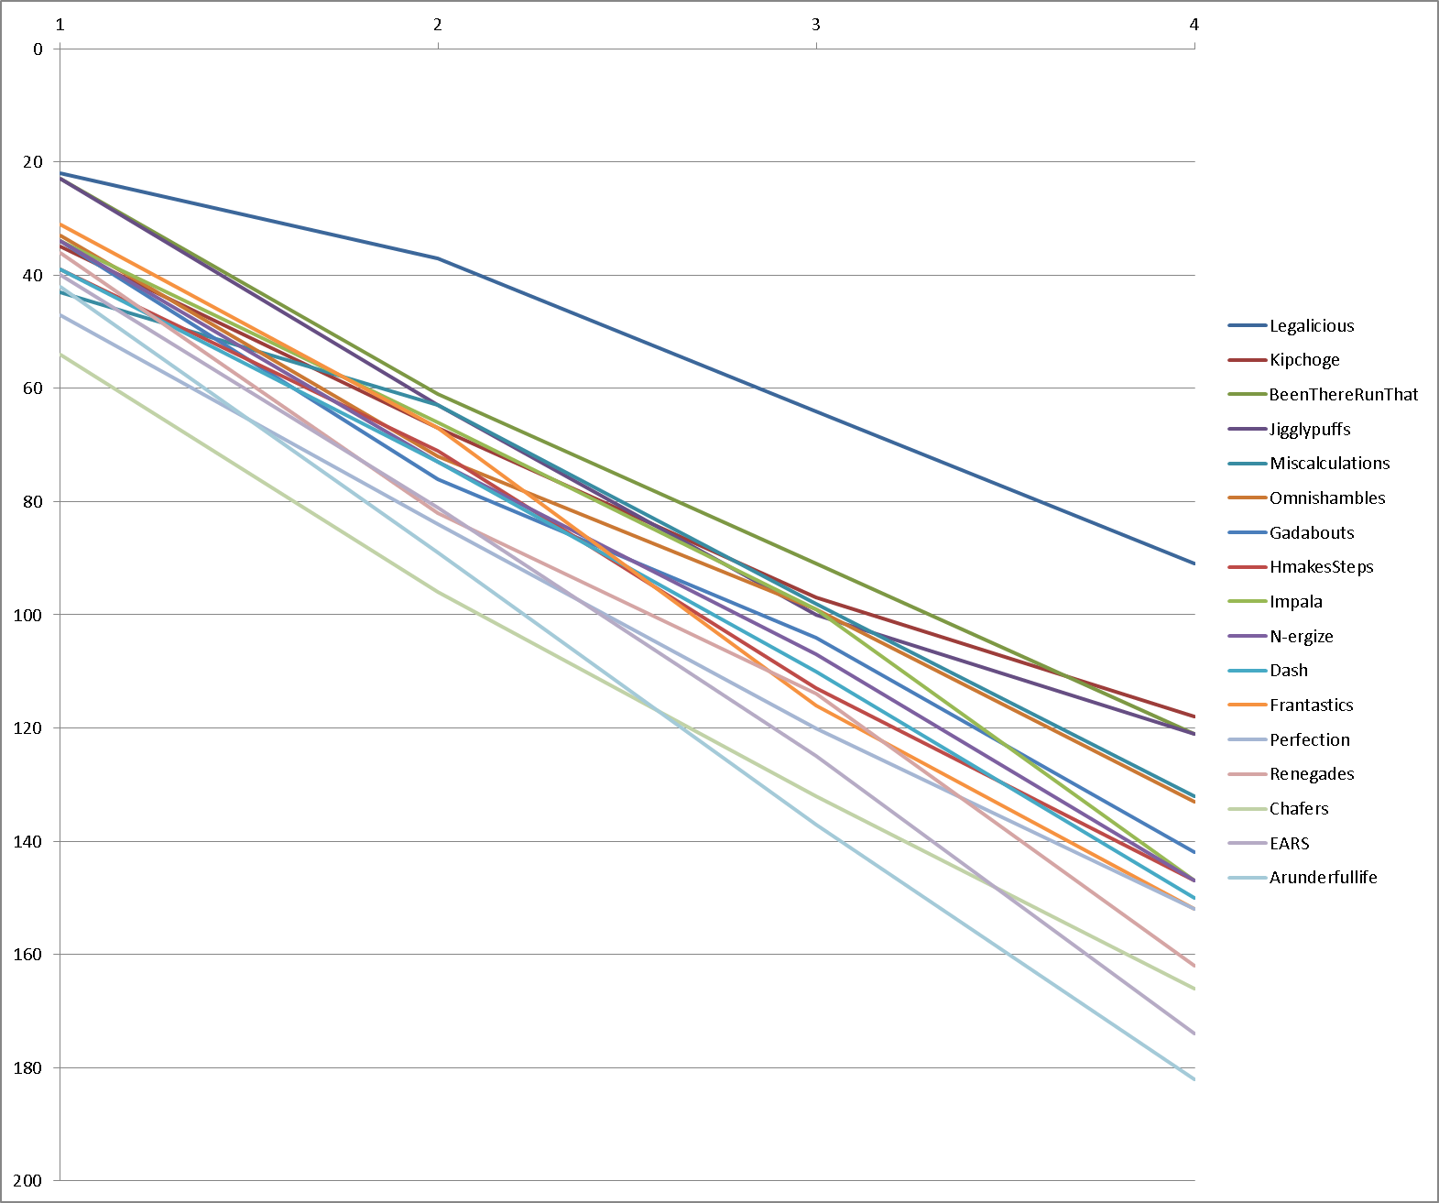

Figure . Team progression (per week)

Appendix 3 – Feedback

Fifty (50) participants provided feedback out of the possible seventy-three (73), i.e. 68.5% of total participants. Questions and cumulative answers can be seen in the table below:

|  |  |  |  |  |
| --- | --- | --- | --- | --- |
| Question | Answers | | | |
| In how many events did you participate (1-4)? | 1 | 2 | 3 | 4 |
| - | 1 (2%) | 4 (8%) | 45 (90%) |
| If you ran less than 4 events, it was because: | of injury | of other commitments | N/A |  |
| 5 (100%) | - | - |  |
| Did you get a PB? | YES | NO | N/A |  |
| [1M TT] | 31 (69%) | 14 (28%) | 5 (1%) |  |
| [5K TT] | 4 (8%) | 44 (88%) | 2 (4%) |  |
| [10K TT] | 6 (12%) | 43 (86%) | 1 (2%) |  |
| [SLR] | 12 (24%) | 37 (74%) | 1 (2%) |  |
| *TOTAL* | *53 (26.5%)* | *138 (69%)* | *9 (4.5%)* |  |
|  | Min | Max | Average | Std. Deviation |
| Did this competition improve your running? | 2 | 10 | 7.42 | 1.79 |
| If you chose a score <5, can you tell us what we could have done differently? | Free text | | | |
| Did you find the event inclusive? | 5 | 10 | 9.16 | 1.17 |
| Did you feel you were encouraged to participate/perform? | 6 | 10 | 9.24 | 1.01 |
| Did you enjoy it? | 6 | 10 | 9.34 | 0.99 |
| How would you rate the communication with your team? | 5 | 10 | 8.86 | 1.13 |
| How would you rate the communication with the organisers? | 6 | 10 | 9.40 | 0.94 |
| How did you find the submission of the weekly results? | 7 | 10 | 9.36 | 0.84 |
| How did you find the presentation of the weekly results? | 7 | 10 | 9.74 | 0.59 |
| Best thing about the BvH444 was... | Free text | | | |
| Next time, we should improve... | Free text | | | |
| I would also like to say that... | Free text | | | |
| This survey is anonymous. But if you would like us to get back to you, leave us your name! | Free text | | | |

Table . Feedback questionnaire

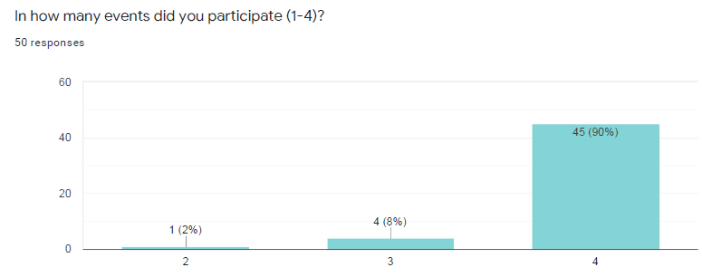

Figure . Participation

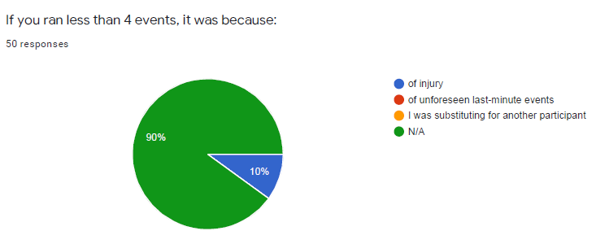

Figure . Reasons for not participating

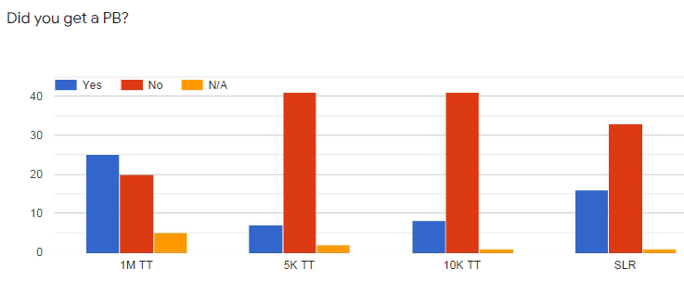

Figure . Personal Bests (PBs)

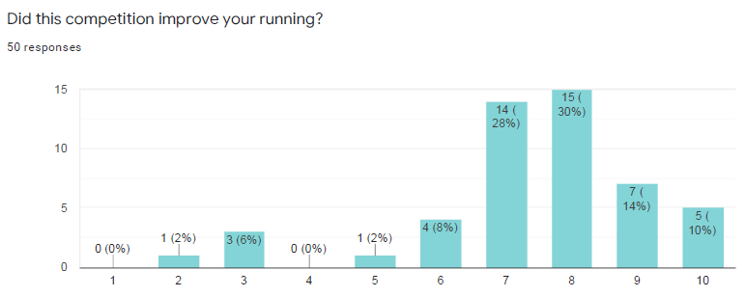

Figure . Running improvement

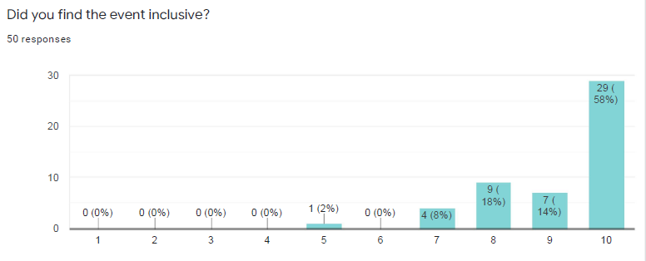

Figure . Inclusiveness

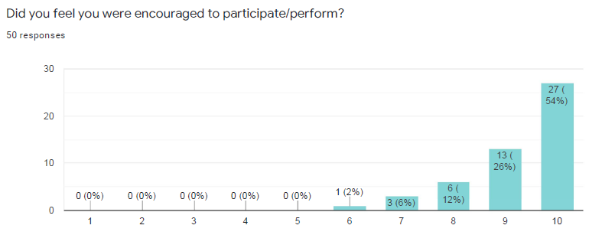

Figure . Encouragement

Figure . Enjoyment

Figure . Communication (team)

Figure . Communication (organisers)

Figure . Results submission

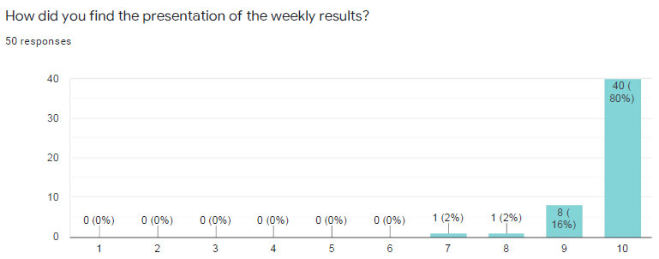

Figure . Results presentation

|  |  |
| --- | --- |
| ***Best thing about the BvH444 was...*** | |
| * Team and PB * Being part of a team. * Running a huge 5km PB and meeting more harriers * Meeting other members of the club. * helped me to get motivated and push myself again * Teamwork * Mixing the teams and giving everyone chance to get to know other club members, participate and do their best * Fun * Smashing my 1 mile PB 👍 * Great to be part of a supportive team and enjoyed running out of my comfort zone. Also enjoyed being back in my comfort zone on days when I wasn't attempting a challenge. * Having something to aim for again. Also the strategy of when to do which event was quite fun to think about. * It really encouraged me to do both short and long runs, and meant that I met more people. I liked the fact it was with the same group over a number of weeks. * It made me run further than I had done for over a year. * Range of different events to suit different people. * Friendly competition * Pushed me to up my training. Did my longest long run since lockdown. * Range of events * Having a more complex/long lasting event to take part in * Some competition during lockdown. 1mile TT something I have not done before * Getting to know new people on my team * Getting to know other Harriers * The banter between our teammates 👍🏻 * Being in a team and waiting for the results each week ca * Different events * Forced me to run both shorter and longer distances as during lockdown I've only been running 10k s * Team spirit * A good way of maintaining some competitive running at a time when there are no races. | * Chatting with my club mates and supporting and celebrating with them * Everything * The chance to push myself when races aren't on! * Xenofon's stats and enthusiasm * The support from my teammates * Extra motivation to get back and run after lockdown. Enjoyed the team competition aspect of it. * The extra motivation from wanting to run well for the team - I entered needing something to keep me focused while there are no races and finished having given it more than I would have done for an ordinary race. * Teamwork, support and positivity from other members & my team * team spirit * Meeting new team mates (virtually). Results * Really fun! * Everything! Loved my team and the results analysis was great * The team spirit and competitiveness * Seeing how my running has taken place since my injury * My Team, we had a great laugh * Over 4 weeks , gave feeling on being in a team and working together - very supportive. * Winning!! I mean being part of a team and everyone giving it their all ! * The fact that distance as well as pace runners could shine! * the team spirit * The different distances and being in a team. * Everyone doing all events, legs for steady long runners and faster, great fun waiting to see weekly results, team were fantastic really encouraging * Running for fun rather than usual commute, joining up with other BvH for NWP |

Table . Positive comments (free text)

|  |  |
| --- | --- |
| ***Next time, we should improve...*** | |
| * The long slow run was a difficult one to compare people given the different running goals people had but that said I did a really fun long run (that wasn’t actually that long!) * Not sure about the SLR, maybe set some boundaries on that. * SLR rules * I can’t think of anything I would change * Nothing * Can't think of anything! * You could have a predicting pacing one instead of a speed one to make it even more competitive. The three speed ones (1m, 5k,10k) were all won by fairly similar people so taking out the 5k and making it ‘predict your pace for a 5k’ would make it even more inclusive. * I wonder if some of the slower runners might have felt under pressure to run faster * Restrict time on the long run to 3 hours, reduces the risk of injury, but still allow people to run long distances. * Maybe something like elevation/time prediction to be more inclusive of slower runners * It has been a brilliant event. Thanks organisers!! * It was all good * Nothing it was very good * I can’t comment on any negatives as there wasn’t any for me. * Can't think of anything * Different events * Nothing * Maybe the chance to reward points if you have a PB! This give the chance to the not so good runners to go up in the leaderboard * Maybe set distance for the longest run, but enjoyed it either way! * coaching/guidance for the individual events | * I thought it was great! * Be good to see even more people entering * Can’t think of anything * the long run have a time limit * Nothing! It was awesome * Perhaps a hilly run? * Nothing * Winners medals 🏅🤣 * Don’t think any improvement care needed * Nothing * Could do fastest from each athlete group(1-4). Appreciate this would be more work but may increase the friendly competition and make the slower athletes feel recognised. * 🤷🏼‍♀️possibly the substitution process * Perhaps the seeding. We had two slow runners and two fast runners but no medium paced runners. * I think it was already good enough * Not sure it could be improved on. * I found it tricky to get suitable routes due to trying to avoid road crossings and needing to finish at start point- but appreciate this was to remove any elevation benefits. If doing the race again could one leg be against own performance eg when I do a club route Strava tells me it’s faster or slower than x number of matched runs. Or aiming for one TT to be against own PB w + or - scores- this could be over complicated! Still having some legs on absolute speed. |

Table . Improvement comments (free text)

|  |  |
| --- | --- |
| *I would also like to say that...* | |
| * Great event which I thoroughly enjoyed! * Next time it would be great if there could be a confirmation email for registration * Loved the results presentations! * Thank you to Xenofon for all your work to bring us this challenge! * Thank you * Thank you for organising it * I liked the fact that it pushed me to do longer runs as I have really missed that since we can't do Monday nights. * As a slower runner I felt each week like I was letting my team down (nothing they did not said made me feel like this). It ended up feeling pressured and stressful and I don't think I performed as well as I could have as a result. * Thanks for the all the hard work you put into it over the month! * It was a brilliant concept and great fun - thank you! * Excellent organisation, great idea. * Overall a really well thought out event * See above * It was a great well organised event * I think I prefer the one event formats, just personal preference but I found it quite difficult to fit the run in around training schedule every week for 4 weeks. * I enjoyed this very much thank you again Xenofon,. A great series of events Brilliantly put together and rolled out over the 4 weeks * I am so grateful for the time, effort and organisation that went into making this event happen. * Thank you. It has been great fun * Great organization! Great competition * Thank you it was ace * Awesome event! Thank so much for running it :) * Thanks Xenofon for an outstanding virtual event. Well done! * Well organised event & results very well presented. Thanks for all your hard work, much appreciated | * I loved every minute of it.. * Xenofon is a legend * I was nervous about signing up to this as the pool 4 runner I knew I would be the "handicap" member of the team but it was so inclusive and the emphasis was on fun, and personal achievement and improvement, my team and the event as a whole made me feel really good about every single run. * Huge thank you for organising! Loved it! * Xen this was an amazing event well done! * It was great being part of a team and seeing everyone trying to beat people. * Xenofon you put some great work into putting this together with all the statistics -Thanks again. * Great idea, great presentation of results. Although didn’t get pb in 5k ran fastest for 8 years, without that push of competition I don’t think I would have done this. A big thank you . Also had a fab supportive team . * It was brilliant- a huge thank you for all your hard work! * This was the most imaginative virtual event so far. Thanks for creating it! * I really enjoyed it * This was so much fun to take part in and I was really pleased with what I managed on each leg. I’ve re-evaluated my own expectations of my speed and entered a marathon as a result of my long run!! Thanks for all the work to organise such a brilliant event that really fulfilled all our aims and was a fantastic way to spend July competing. * Looking for to the next event 🙂 |