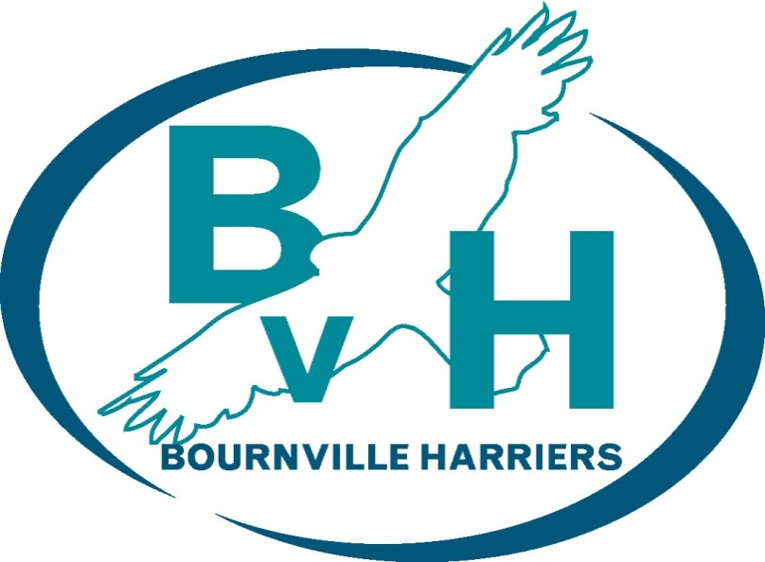

Bournville Harriers

Club Constitution

As adopted by the members on 27th March 2017

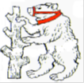

BOURNVILLE HARRIERS CLUB CONSTITUTION
- NAME
  - The club name shall be Bournville Harriers (abbreviated as BvH).
  - It will be affiliated to the appropriate athletics governing bodies ("the Governing Bodies").

- AIMS & OBJECTIVES
  - In line with BvH's core values of Performance, Participation, Encouragement and Enjoyment, the aims and objectives of BvH shall be to:-
- offer structured training, coaching and competitive opportunities that are fair and open to everyone;
- foster the enjoyment of running for personal achievement, improvement and friendship;
- encourage an active role within BvH by all members;
- provide opportunities for running both on and off-road (including track) and to promote running in the local area;
- Organise teams to represent BvH in championship events, affiliated leagues and other competitions agreed by the BvH Committee.
  - BvH shall seek to ensure a reasonable duty of care to all its members. BvH is an adult running club, where individual members must also accept a measure of responsibility in these matters.

- MEMBERSHIP
  - BvH shall consist of ‘amateurs’, as defined by the rules of the Governing Bodies.
  - To be eligible to join BvH, members must be 18 years and above.
  - The BvH Committee may establish different classes of membership, prescribe their respective privileges, and set the amounts of annual membership fees payable (subject to the approval of the BvH Members by vote at the Annual General Meeting (‘AGM’)).
  - Each BvH Member shall be entitled to vote on decisions at BvH AGM's and Special General Meetings ("SGM's").
  - Application for, and renewal of, membership will be through the completion of a BvH membership form and payment of the relevant annual membership fee. The annual membership fee will be due on April 1st of each year.
  - By completion of a BvH membership form, the member shall be deemed to have agreed to abide by this Constitution, a copy of which is available on the website.
  - A membership form must have been submitted to BvH and the relevant membership fee paid for the current year before a member can compete for BvH.
  - All members shall ensure BvH has their most up-to-date details (the details of interest being those collected through the membership form).
  - BvH membership is not transferable to another person.
  - The Membership Secretary will maintain a database of individual member details in accordance with the Data Protection Act 1998. This information will be treated as confidential and only used in compliance with Governing Bodies’ regulations, verification on entry for team/league/championship events, BvH records/rankings and BvH communications regarding activities/events.
  - BvH does not tolerate any member who causes physical or mental harm, harassment, discrimination, or defamation of any of its members. Any member may be cautioned or excluded from membership of BvH if their conduct has been, or is likely to be, prejudicial to the interests of BvH. Any member expelled will have the right to appeal to the Committee no later than two weeks from the date of expulsion.
  - Should any BvH member decide to leave BvH (e.g. to join another club), under the Governing Bodies’ rules concerning 1st claim club status, the member will need to resign by providing notice in writing or by email. In order to claim reimbursement of any remaining membership fee paid in advance the member shall provide a fully completed hardship form, which must be submitted to the Membership Secretary. Two members of the BvH Management Team shall be required to sign off such reimbursement.

- CLUB MANAGEMENT
  - The BvH Management Team shall consist of:-
- Chairperson;
- Vice Chairperson;
- Club Secretary;
- Club Treasurer;
- Membership Secretary; and
- Two Ordinary Members.
  - All of the BvH Management Team are elected or re-elected from amongst and by the BvH Members at an AGM.
  - With the exception of the Chairperson, all the BvH Management Team are elected for a period of one year, but may be re-elected to the same position or another position the following year. The Chairperson is elected for a period of two years but may be re-elected to the same position or another position thereafter.
  - The Chairperson is expected to ensure a smooth transition of duty when standing down which may include taking up the post of Vice Chairperson.
  - Should any office on the BvH Management Team remain vacant after AGM elections, the officer standing down is expected to provide advice, support, and expertise on the matters of their post until a replacement officer is found.

- BvH COMMITTEE
  - The affairs of BvH shall be administered by a Committee comprising of the BvH Management Team and up to 10 other Members (the BvH Officers). All BvH Officers are elected or re-elected from amongst and by the BvH Members at an AGM. BvH Officers are elected for a period of one year, but may be re-elected to the same position or another position the following year.as follows:-
BvH Officers shall consist of:-
- Head Coach;
- Race Events Co-ordinator;
- Communications Officer;
- Team Managers (Men/Women) Cross Country;
- Team Managers (Men/Women) Road Relays;
- Membership Development Co-ordinator;
- Kit Secretary;
- Social Secretary; and
- Up to 2 additional members co-opted by the BvH Committee (Co-opted Committee Members).

(Role descriptions are available and can be amended by the BvH Committee.)

  - The BvH Committee shall:-
- administer the affairs of BvH on behalf of the members;
- keep accurate accounts of the finances of BvH through the Treasurer, and which shall be audited and presented at every AGM for approval by the BvH Members;
- maintain a bank current account and the following officers shall be authorised to sign BvH cheques: any two from four of the elected Committee approved as cheque signatories;
- Be entitled to fill any vacancies on the BvH Committee arising during the year or not filled at the AGM from amongst the BvH Members, with such Committee Members to remain in post until the next AGM but who may be re-elected to the same position or another position the following year.
  - The BvH Committee shall meet on a regular basis (usually every month) and not less than 6 times per year.
  - A quorum for meetings of the BvH Committee shall be more than half of the elected Committee Members and must include either the Chairperson or Vice Chairperson.
  - Should the BvH Management Team meet separately, the quorum shall be four and must include either the Chairperson or Vice Chairperson.
  - All decisions shall be by simple majority vote. The Chairperson (or Vice Chairperson in the absence of the Chairperson) will have a casting vote in the event of a split decision.
  - The BvH Management Team and BvH Officers may delegate to a sub-committee, comprising at least 2 members of the BvH Committee, as and when necessary.

- ANNUAL GENERAL MEETING (AGM)
  - BvH AGM will be held not later than the end of March each year. The Club Secretary shall give 21 days’ written notice to BvH Members of the AGM together with a copy of the agenda.
  - ALL paid-up BvH Members are expected to attend BvH AGM.
  - The business of the AGM will be to:-
- confirm the previous AGM’s minutes;
- receive the audited accounts for the year from the Treasurer;
- receive the annual report from officers of the Committee;
- review the membership rates and agree them for the forthcoming year;
- elect the BvH Committee; and
- Transact any other business received in writing by the Club Secretary from BvH Members two weeks prior to the meeting.
  - With the exception of the Chairperson, all the BvH Committee members are elected for a period of one year, but may be elected to the same position or another position the following year, unless another club member is interested in taking up the post at which point an election will be decided by a majority vote,
  - Motions to be discussed must be forwarded to the Club Secretary at least two weeks before the meeting.
  - One quarter of fully paid up BvH Members will constitute a quorum at an AGM.
  - All decisions shall be by simple majority vote. The Chairperson (or Vice Chairperson in the absence of the Chairperson) will have a casting vote in the event of a split decision.

- SPECIAL GENERAL MEETING (SGM)
  - A SGM may be called by the BvH Committee or on receipt by the Club Secretary of a request in writing from any BvH Member, giving reasons, supported by the signatures of 30 other BvH Members. At least 28 days’ notice of the SGM shall be given.
  - Procedures for the SGM will be the same as for the AGM.

- WRITTEN RESOLUTIONS
  - A written resolution circulated by the Club Secretary to all BvH Members and approval signed or communicated by electronic means by a majority of those entitled to vote at an AGM or SGM of BvH shall be as valid as a resolution actually passed at such meeting.

- CLUB COLOURS
  - BvH running vest shall be ‘Teal’ colour, with a navy blue trim. There is no official BvH colour for running shorts.
  - BvH Members representing BvH at competitive events are expected to wear BvH colours whenever possible to promote BvH. For team events, such as league races and championship races, this is compulsory under Governing Bodies’ rules.

- AMENDMENTS TO THE CONSTITUTION
  - Any amendments to this constitution can only be approved by not less than half of those BvH Members present at a quorate AGM, or SGM called specifically for that purpose.
- CLUB DISSOLUTION
  - A resolution to dissolve BvH can only be approved by not less than two thirds of those BvH Members present at a quorate AGM or SGM called specifically for that purpose.
  - After dissolution, and subject to the approval of the Committee and BvH Members, any funds and assets remaining, after the satisfaction of all its debts and liabilities, shall be given or transferred to such other clubs or associations having similar aims and objectives to those of BvH.

Signed

………………………………………... ...………………………………………
Chairman Club Secretary
Dated 2017

